**Natural Language Processing Challenge**

**Description Of The Data:** The data provided in the training set contains a set of images which act as a puzzle and can fit together in pairs. Please find below an example of images that would fit together:  
  
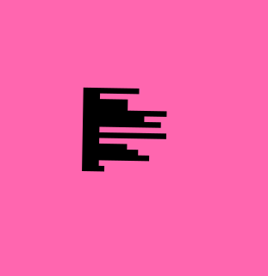  
  
  
  
The **solution.csv** file provided in the same directory contains two attributes: id, and pair. Both attributes represent file names in the training set. From the given solution we can infer that file 1 is a pair of file 854 and they fit together like a puzzle. Same is the case for the entire set of attributes. Please note the whole set of tuples only have one to one mapping.

**Objective Of The Problem:** Objective of the problem is to find the pairs in the test data and write the same to a CSV (comma separated values) file. The solution file would contain two attributes, one would be id and the second would be pair. Please write pairing file names in a CSV file and upload the same for getting a score. Please view the sample submission file as an example of how the solution is to be written.

**Evaluation Metric:** The evaluation metric for this problem would be [precision based accuracy.](https://scikit-learn.org/stable/modules/generated/sklearn.metrics.accuracy_score.html) The accuracy score would be normalized to 100. Accuracy is going to be calculated between the absolute correct submission and the submission made on the platform.